**Data Contract - Versioning**

**Rameshkartik.RS**

**Table of Contents**

Versioning 3

Versioning Strategies 4

Attachment 10

Summary 10

**WHAT’s IN THIS ARTicle?**

* Versioning
* Versioning Strategies
  + Add Member
  + Delete Member
  + Parameter Data Type Change
  + Return Type Change
  + New Method
* Attachment
* Summary

# Versioning

In a software product/project the changes in the requirements are always unavoidable, We should not restrict the customer by saying NO for the changes,but we should welcome them with the right set of techiniques and the processes to respond the changes. The changes in the requirement might cause a changes in the operation,service or in the structure of data being exchanged.In result it cause a changes in WSDL document which leads us the new version of Data Contract. In a simple words ,Once the service is ready and it is deployed in production,any changes in the contracts should be backwards compatible so that the existing clients would not get affected once the changes are deployed. In this article we will discuss the techniques and procedures in order to achieve this versioning facility.

# Versioning Strategies

In this article we will discuss the basic versioning strategies

* Adding new parameter to the operation signature
* Removing parameters from an operation signature
* Modifying parameter types of operations
* Modifying the return value of a service method
* Adding new service method in a service

Adding new parameter to the operation signature

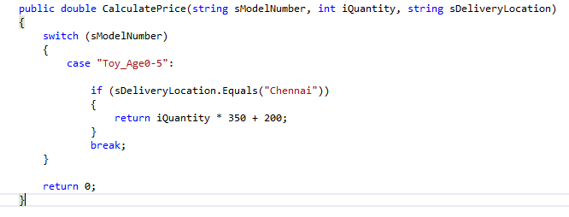

Please look the above snapshot, you can find only three arguments for this service method and this snapshot had been taken before the service method gets changed.

Based on the requirement changes, the service method gets an additional parameter called iDiscountAmount. As like the below snapshot the service method gets changed with an additional parameter.

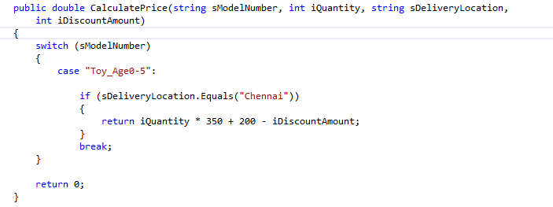

What would happen for the clients who is still having the old reference of service? No problem,the client will remains unaffected, When the service is called by the old method signature, the service will initialize the new parameters with a default values, in our case the additional parameter data type is integer whose default value will be “0.The client will not be disturbed because of the iDiscountAmount parameter and he is still remain unaffected. And the final output will be

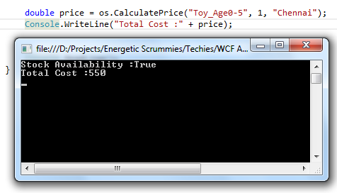

Removing parameters from an operation signature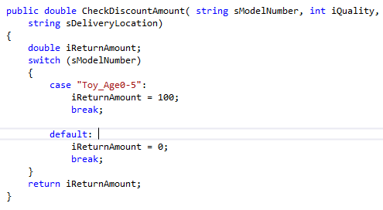

Please look the above snapshot, you can find three arguments for this service method and this snapshot had been taken before the service method gets changed. Based on the requirement changes, the service method removes parameter called sDeliveryLocation. As like the below snapshot the service method removed the parameter.

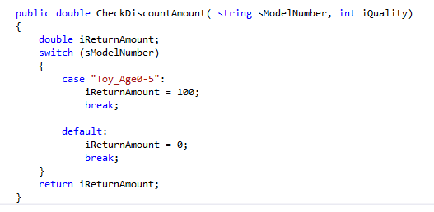

In this case,the client will be sending surplus parameters since he is holding the old service reference, but the surplus parameters are ignored at the service level and this results in data lost at the service. So the client still remains unaffected with the following output

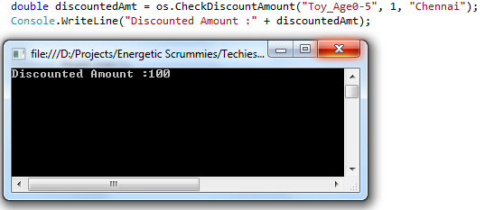

Modifying parameter types of operations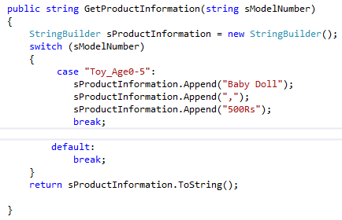Please look the above snapshot, you can find one string data type argument for this service method and this snapshot had been taken before the service method gets changed. Based on the requirement changes, the service method changed the parameter type from string to integer. As like the below snapshot the service method changed the data type of the parameter.

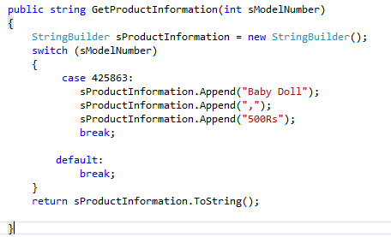

If we run the client without updating the service reference, the result is unexpected. In our case the string data type could be sent through the switch case then no matching cases were available so it returns empty string. The final output will be shown below

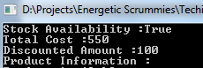

Modifying the return value of a service method

In our case if you find the attached source code the client is actually expecting the string as return value, but the current service implementation returns as array list. If we run the client without updating the service reference, the result is unexpected.

Adding new service method in a service

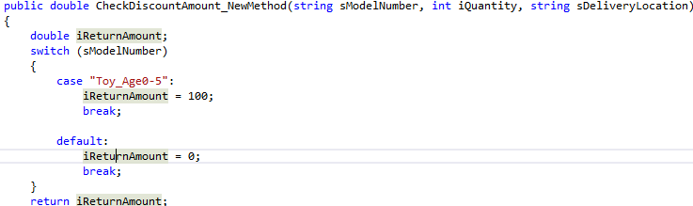

The above one is the new method added in the service which is completely unknown for the client because he is still holding the old service reference. So the client remains unaffected.

# Attachment

Refer the code attachment for further details

# Summary

WCF is a version tolerant, The framework tries its best to serve existing clients with backwards compatibility.